This document is merely to point out the differences in confessional count numbers between my findings and the official numbers posted on Survivor Sucks. The guidelines I use can be found [here](https://docs.google.com/document/d/18ofsPiVWxSejzSjEGlU8KEx4Og2ddEJScCV23RsCPIA/edit?usp=sharing).

**Survivor Sucks Season 27 Counts** ([link](https://goo.gl/photos/WCBNy7zobBXW4PVY8))

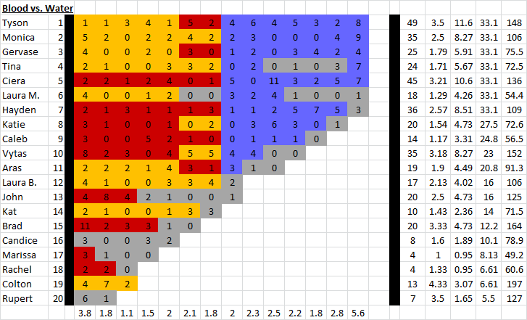

**My Season 27 Counts** ([link](https://goo.gl/photos/R1fuAFCU77VFMvRB6))

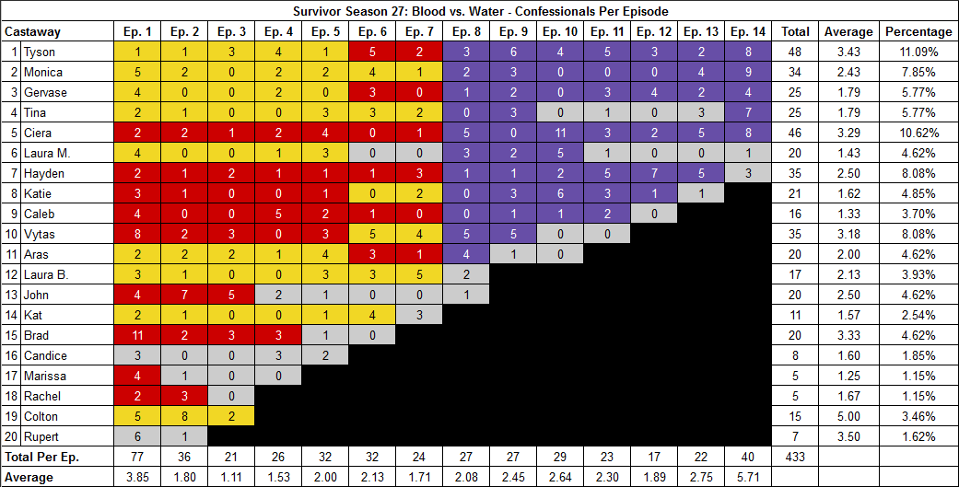

[Survivor Sucks Season 27 thread](http://survivorsucks.com/topic/108360).

**Note:** For Redemption Island themed seasons, I count confessionals post-TC, once castaways arrive at RI, which is a main difference from the guidelines used on Survivor Sucks.

**Differences**

[Episode 01](https://docs.google.com/document/d/1SuxTk8cfrIBqKMnac3Gz1FCEFGtGAtDsqZdYq-4xuNo/edit?usp=sharing)

* **Caleb: 4 (+1)** Caleb has a total of 4 confessionals in Ep1.
  + Confessional #10 in Day 0 next to Colton.
  + Confessional #25 in Day 1 after all 20 castaways are divided into two tribes.
  + Confessional #49 in Day 1 at Tadhana camp when Brad is making the all-male alliance.
  + Confessional #73 in Day 3 pre-TC.
* **Laura B: 3 (-1)** Confessional #38 has a 9s gap which decreases her count to 3.
* **Marissa: 4 (+1)** Confessional #77 is a RI confessional.
* **Colton: 5 (+1)** Confessionals #56-58 are three consecutive Colton confessionals. Between #56-57 there is a 14s gap and confessional #58 is a voice over.

[Episode 02](https://docs.google.com/document/d/1Iyiq3s9UgmZ6o5t98tQDbE5l9lRJMWgmdC69_NyVJ0Q/edit?usp=sharing)

* **John: 7 (-1)** Confessional #14 has a 9s gap.
* **Rachel: 3 (+1)** Confessional #36 is a RI confessional. Also, confessional #10 is a voice over.
* **Colton: 8 (+1)** There are two sets of consecutive confessionals, both of which have a gap of 11s between them.
  + Confessional #4 → 5
  + Confessional #18 → 19

[Episode 03](https://docs.google.com/document/d/1tTsttC5rboK7johMZEZiJJMVgKclq5Yg1ANB9Nae-g8/edit?usp=sharing)

* **Hayden: 2 (-1)** Confessional #17 has a 9s gap.
* **John: 5 (+1)** Confessional #21 is a RI confessional.

[Episode 05](https://docs.google.com/document/d/1nGyDo8tddTGE2NzTnHQoTWdgLPHyGOe9VmUhmLKZKiM/edit?usp=sharing)

* **Vytas: 3 (-1)** Vytas has 3 confessionals with no significant gaps in them (9-11s).
  + Consecutive confessionals #18-19 are on Day 11, are before a commercial break while Caleb and Vytas go out on the boat.
  + Confessional #21 is the first confessional of Day 13, right after the commercial break.
* **Laura M: 3 (+1)** Confessional #32 is a RI confessional.

[Episode 06](https://docs.google.com/document/d/1pSKVzl4ottHjO_ixsQXsm6UVpYMtP8P8fAgK0DNiQtc/edit?usp=sharing)

* **Kat: 4 (+1)** Confessional #32 is a RI confessional.

[Episode 07](https://docs.google.com/document/d/1-NxpW6p_W9ZFNXkVf4-MYUwax1FS_4t_yYPLOPGH9ro/edit?usp=sharing)

* **Monica: 1 (-1)** Confessional #19 has a 9s gap.
* **Vytas: 4 (-1)** Confessional #21 has a 9s gap.
* **Laura B: 5 (+1)** Confessional #24 is a RI confessional.

[Episode 08](https://docs.google.com/document/d/1BQRq1-8D3EE-3qko5ylxSEhOVoLQY35axB3p9JulN90/edit?usp=sharing)

* **Tyson: 3 (-1)** Confessional #20 has a 9s gap.
  + **Note:** When Tyson finds the HII (confessional #15), there are elements of “on the fly” that also has a 9s gap. Even if the “on the fly” segments are eliminated, it doesn’t alter the count. Below is a breakdown of the confessional:
    - Ta-da! I’m definitely not sharing this with anybody else right now. I mean, if it becomes my advantage to share it with somebody in my alliance to keep them in the game and push somebody else out, then that’s something I’ll definitely do. But right now, nobody needs to know I have it. (19:54 →) **[Tyson crouched talking to camera]** I stepped on that probably like, twenty times. Let's see how sweet it is. I hope it's solid gold. Try it on, make sure it fits. (← 20:03 = 9s) Hooray! I’ve never had an idol before and I’ve also never won the show before. So, do those correlate directly with one another? Probably not, but at least it’s a little more advantage.
* **Vytas: 5 (+1)** Vytas has five confessionals:
  + Confessional #1 on Day 18 is the first confessional.
  + Confessionals #16-17 & 19 on Day 19 when Aras and Vytas have a private talk.
  + Confessional #22 is the first confessional of Day 21 post IC back at camp.
* **Aras: 4 (+1)** Confessional #27 is a RI confessional.

[Episode 09](https://docs.google.com/document/d/1EDkvjsU8uQE40EPQ_zMRn6qCt0Eue0A4ialoQyTeKoc/edit?usp=sharing)

* **Tina: 3 (+1)** Confessional #26 is a RI confessional.
* **Vytas: 5 (+1)** Confessional #27 is a RI confessional.

[Episode 10](https://docs.google.com/document/d/1ujJdBTg5o99kfYMWg9EtRURu5HxkRbOaKCQgQEXWyuA/edit?usp=sharing)

* **Laura M: 5 (+1)** Confessional #29 is a RI confessional.

[Episode 11](https://docs.google.com/document/d/1UAijUnQ1c-BXnc5mKSdI0XIB8P8zuQLaKaTb1x2_Rfc/edit?usp=sharing)

* **Caleb: 2 (+1)** Confessional #23 is a RI confessional.

[Episode 12](https://docs.google.com/document/d/1uxVSEhGiRnp26fJxhde_2a5IFaS7Pf269PVvH3j1lW4/edit?usp=sharing)

* **Katie: 1 (+1)** Confessional #17 is a RI confessional.
  + **Note:** Confessionals #6-7 are when Tyson looks for and finds the HII. Both of them have elements of “on the fly” mixed with confessional interviews. There is no significant gap that would alter his count.

[Episode 14](https://docs.google.com/document/d/1qWBW0VW-J9pfLvh9kl1dF6dD_m4hpAjaQjO3B4iKhGs/edit?usp=sharing)

* **Ciera: 8 (+1)** Confessional #13 has a 10s gap.

**No Change**

* [Episode 04](https://docs.google.com/document/d/1YMHm3JqIcXA_ZW7fqxJJNTAHvPmYY9UFmw2EeciqyCU/edit?usp=sharing) (**Note:** Confessional #26 is a RI confessional that was originally counted on Survivor Sucks when the episode aired, so there is no change in Candice’s count as per my guidelines)
* [Episode 13](https://docs.google.com/document/d/17HfrnTsY_f5Otlk38dV0qWNbdB5ihBYLUxfO0EPsuO4/edit?usp=sharing) (**Note:** Regarding Hayden in this episode, Confessional #19 has a 9s gap, which would bring his count down by 1 on this episode, but I also included Confessional #22 which is a RI confessional. This means, there is no overall change for Hayden on this episode in count, but if you don’t count RI confessionals, he would have 4.)

|  |  |  |
| --- | --- | --- |
| **Castaway** | **Count (RI in parenthesis)\*** | **Change** |
| Colton | 15 | +2 |
| Rachel | 4 (+1) = 5 | +1 |
| Marissa | 4 (+1) = 5 | +1 |
| Kat | 10 (+1) = 11 | +1 |
| John | 19 (+1) = 20 | - |
| Laura B. | 16 (+1) = 17 | - |
| Aras | 19 (+1) = 20 | +1 |
| Vytas | 34 (+1) = 35 | - |
| Caleb | 15 (+1) = 16 | +2 |
| Hayden | 34 (+1) = 35 | -1 |
| Laura M. | 18 (+2) = 20 | +2 |
| Ciera | 46 | +1 |
| Tina | 24 (+1) = 25 | +1 |
| Monica | 34 | -1 |
| Tyson | 48 | -1 |
| **Total** | **433** | **+9** |

*\*In this column, the number in parenthesis corresponds to any post TC RI confessionals I counted, and the equal corresponds to my final total for that castaway, which is also reflected in the overall change in the third column. If you don’t count RI confessionals, the total number for the castaway will be to the left of the parenthesis.*

**Revised Sucks Counts** ([link](https://goo.gl/photos/egfBHsWfYEcAW2Vj7))

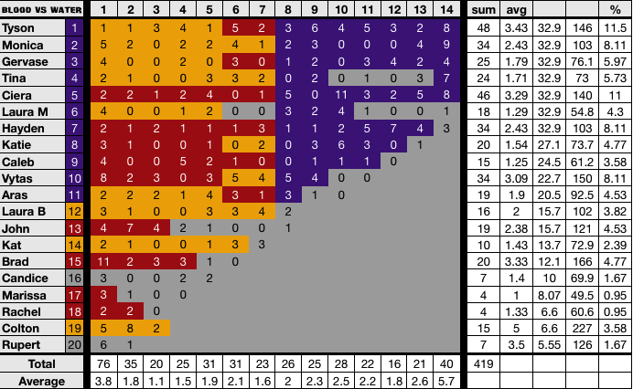

**Differences:** All my findings are reflected in the verified counts. However, all Redemption Island confessionals were excluded from the count.